ChrisCruz.co — Customer-Facing Product Examples
This document is designed for prospective customers. Each example explains business value and customer-facing outcomes.

AI Email Studio
Customer outcome: Create and refine campaign-ready emails in minutes, with consistent tone and stronger response rates.
What the customer gets:
- Faster campaign production with AI-assisted rewrite controls.
- Built-in preview workflow before send to reduce mistakes.
- Cleaner, on-brand messaging for outbound and follow-up emails.
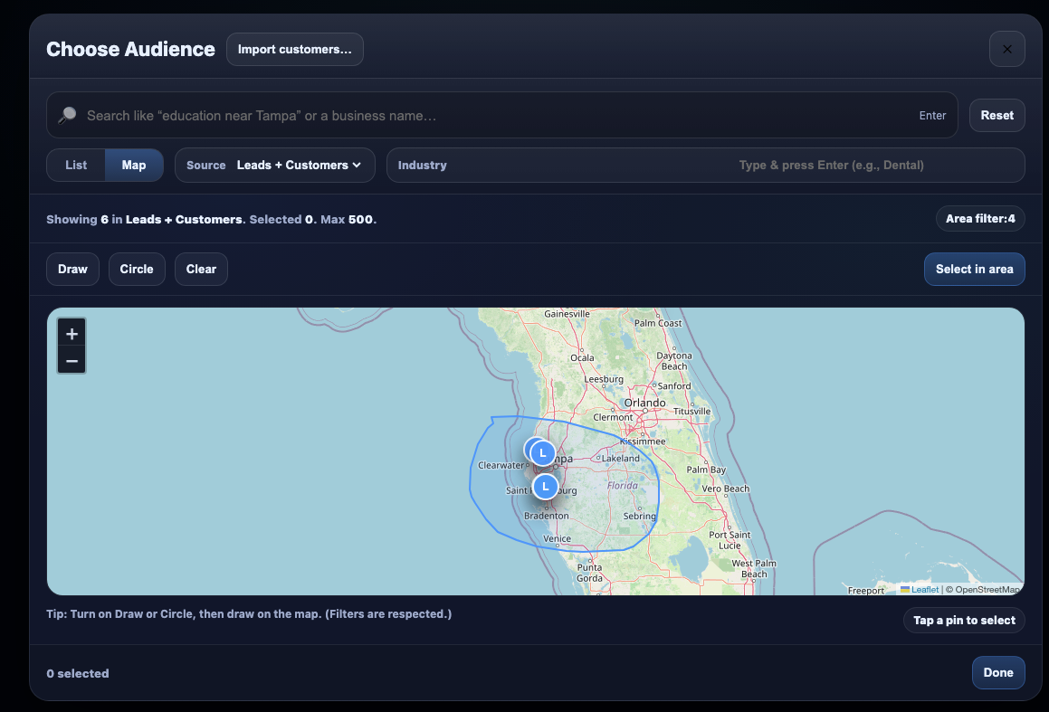

Audience Builder (Map + Filters)
Customer outcome: Target the right prospects by location and profile, so your outreach is more relevant and efficient.
What the customer gets:
- Map-based audience selection with draw/radius tools.
- Filter logic by source, industry, and customer type.
- Lower list waste and better-fit lead selection.
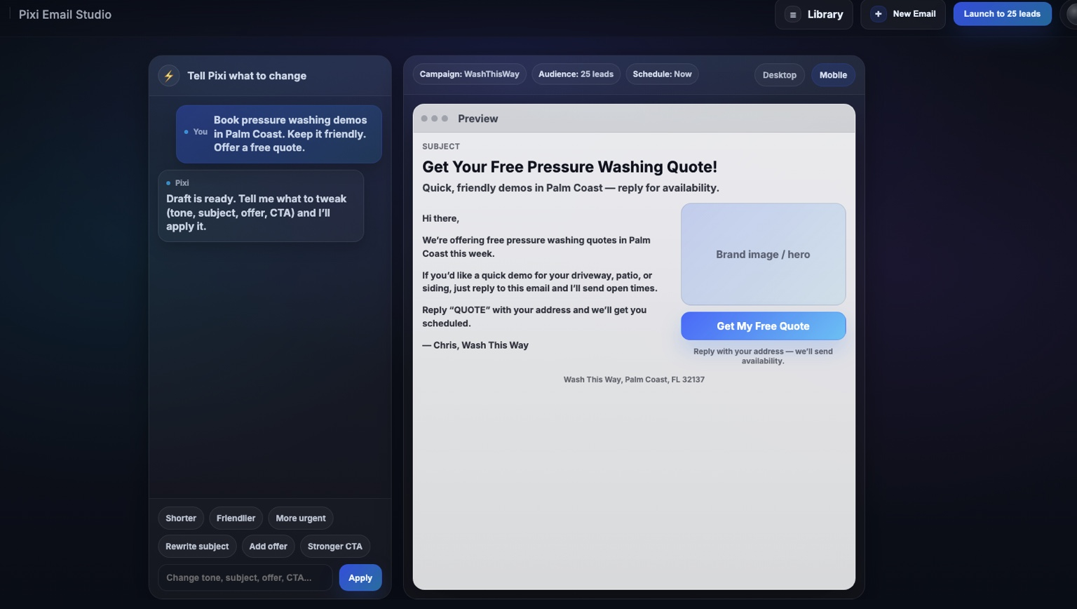

Campaign Operations Workspace
Customer outcome: Run campaigns from one place—compose, test, and launch with better operational control.
What the customer gets:
- Unified compose + results workflow.
- Sender/reply settings and campaign metadata controls.
- A repeatable operating flow your team can use daily.
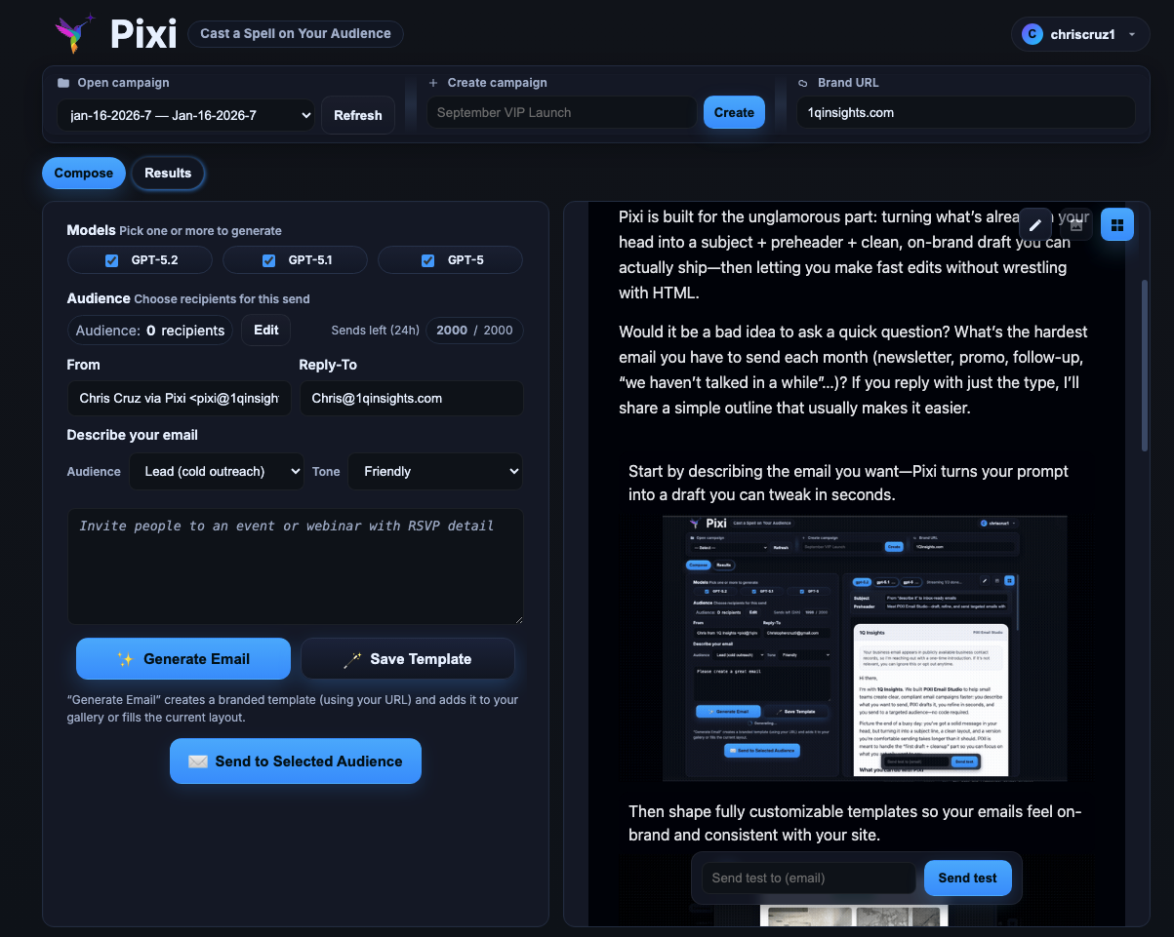

Instant Insights Dashboard
Customer outcome: Turn business questions into quick answers with KPIs, exports, and actionable summaries.
What the customer gets:
- Prompt-driven analysis over business data.
- Clear KPI cards for sales, cost, and profit.
- CSV/Excel/PDF export options for handoff and reporting.
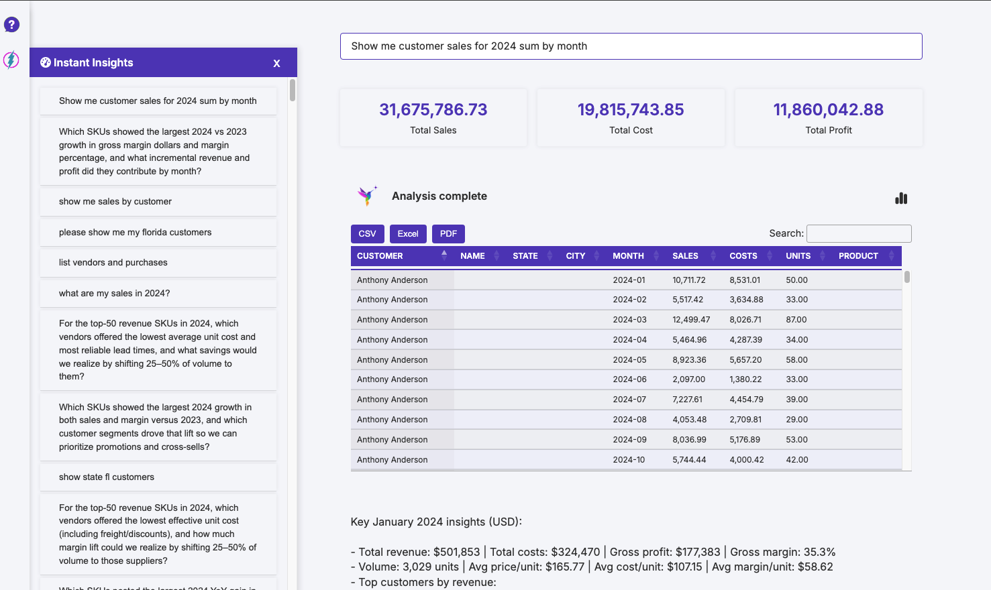

Model Review & Decision Interface
Customer outcome: Compare AI tools quickly so you can pick practical options without guesswork.
What the customer gets:
- Side-by-side scoring for quality, speed, and cost.
- Search/filter tools for faster shortlisting.
- Decision-ready view for teams buying or testing AI tools.
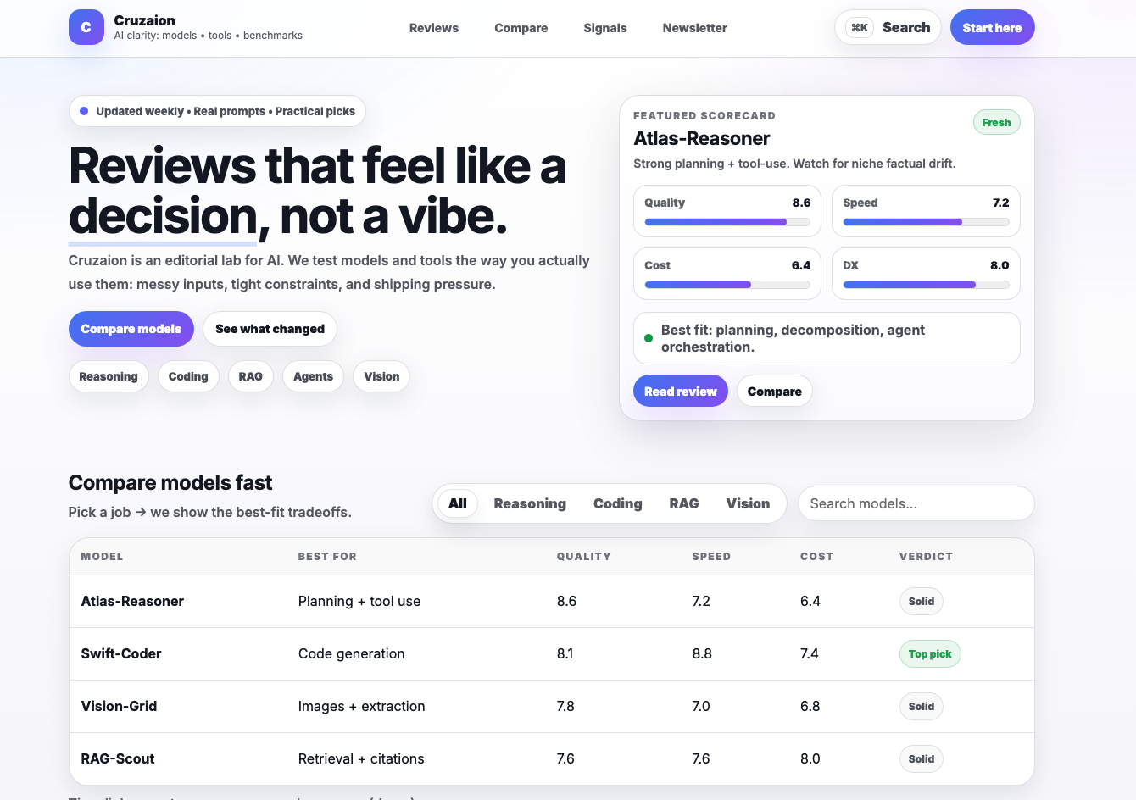

Local Growth Insights Experience
Customer outcome: Share local market trends in a clean format stakeholders can understand fast.
What the customer gets:
- Readable trend cards and weekly insight modules.
- Content blocks for reports, interviews, and business highlights.
- A presentation style that supports non-technical decision makers.
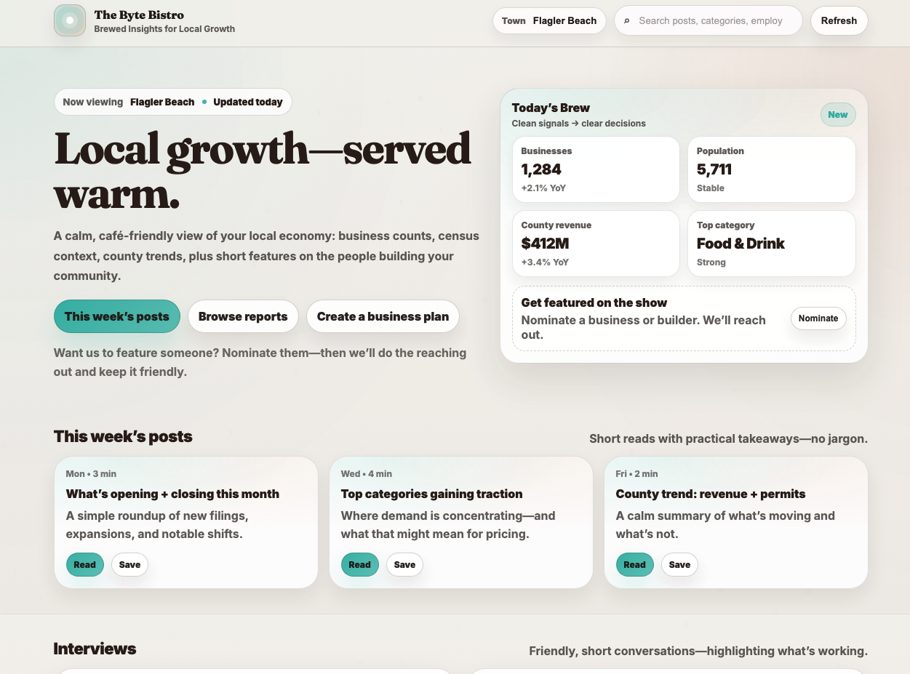

Visual Content Commerce UI
Customer outcome: Showcase visual products with stronger browse paths and conversion-focused layout.
What the customer gets:
- Category-led browsing and featured content sections.
- Prominent action points for inquiry/commission requests.
- A polished storefront feel with clear navigation.
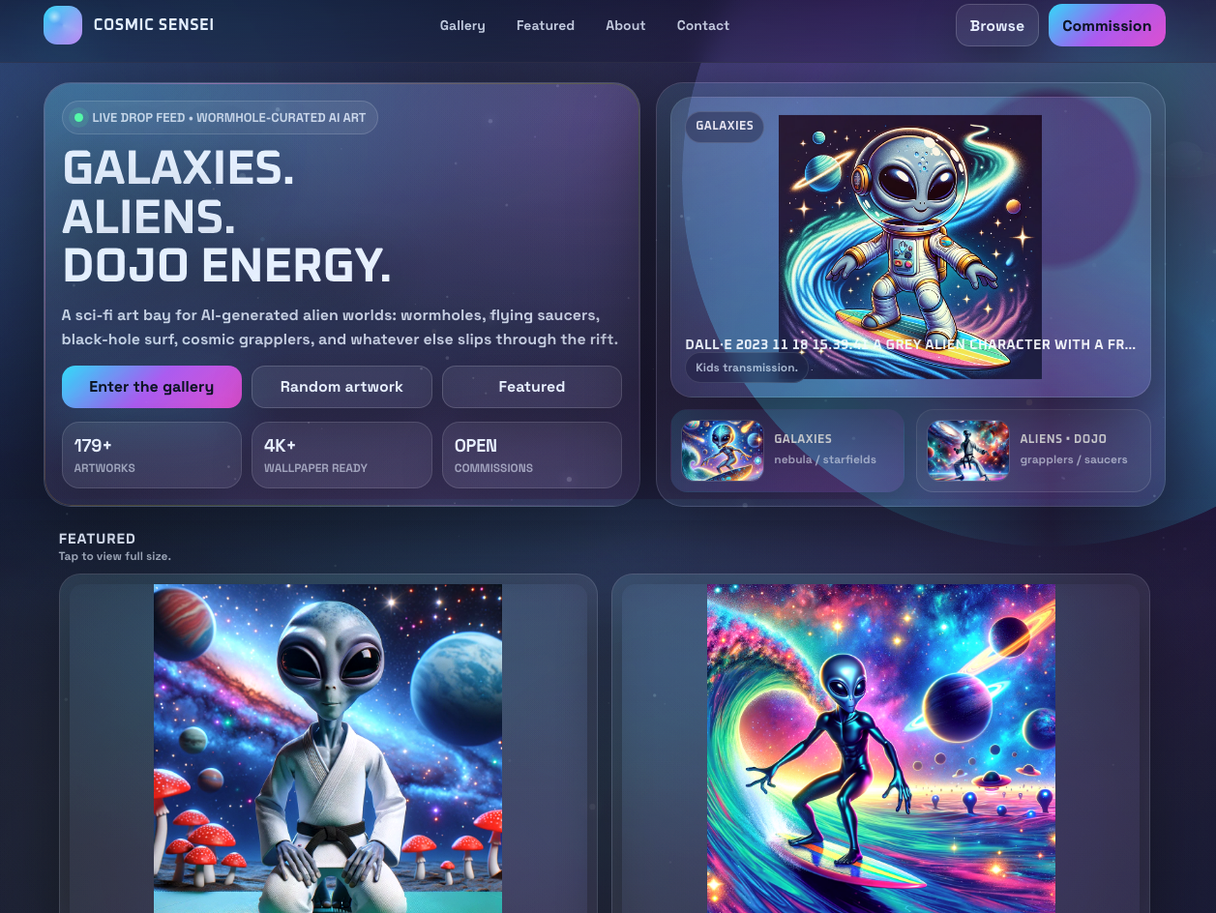

Family-Safe Content Feed
Customer outcome: Organize mixed media content into a format that is engaging, safe, and easy to explore.
What the customer gets:
- Tag/category-based browsing for fast discovery.
- Feed layout optimized for images and short clips.
- Friendly tone system designed for broad audiences.
